The Five Minus One Students Software Development Team

Monetary Counting System

Analysis Document
for

George's Pizza Shop


Prepared For: | Mr. Ken George, George's Pizza Shop
Prepared By: | I. M. Hungry, Project Leader
 | M. B. Bacon
 | A. M. Mushroom
 | N A. Pepperoni

October 14, 2004
Table of Contents

List of Figures
Figure 1. Monetary Counting System Context Entity-Relationship Diagram 5
Figure 2. Account Information Store Entity-Relationship Diagram 6
Figure 3. Name Entity Relationship Diagram 7
Figure 4. Account Class ORM 8
Figure 5. Usage Class ORM 8
Figure 6. Monetary Counting System Level 0 DFD 9
Figure 7. Monetary Counting System High-Level Use Case Diagram 11
Figure 8. Elaborated Use Case – UC1 Validate User Login 13
Figure 9. Elaborated Use Case – UC8 Ask for Help 14
Figure 10. Cashier Successfully Logs into MCS 18
Figure 11. Cashier Unsuccessfully Logs into MCS 18
Figure 12. Administrator Successfully Logs into MCS 20
Figure 13. Administrator Unsuccessfully Logs into MCS 20

List of Tables
Table 1. Data Store Cross-Referencing 6
Table 2. System Usage Narrative 10
Table 3. High-Level Use Case Glossary 12
Table 4. Elaborated Version of UC1 Validate User Login Use Case Narrative 13
Table 5. Elaborated Version of UC8 Ask for Help Use Case Narrative 14
Table 6. Account Class 15
Table 7. Instruction Manual Class 15
Table 8. Login Class 16
Table 9. Usage Class 16
Table 10. Use Case Table Cross-Referencing 17
Table 11. Use Case 1 - Validate User Login as Cashier 19
Table 12. Use Case 2 - Validate User Login as Administrator 21

List of Report Sections
INFORMATION DESCRIPTION
1. Entity Relationship Diagrams (ERDs) – Analysis Document Modeling 5
a. Top Level Entity-Relationship Diagram 5
b. Entity-Relationship Diagram – Account Information Store 6
1. Entity-Relationship Diagram – Name 7
2. Object-Relational Models (ORMs) 8
a. Account Class ORM 8
b. Usage Class ORM 8
Functional DESCRIPTION
3. System Context Diagram Model 9
a. Context Diagram 9
4. System High-Level Use Case Model 11
a. High-Level Use Case Diagram 11
5. Elaborated Use Case Diagram Models 13
a. Elaborated Use Case – UC1 Validate User Login 13
b. Elaborated Use Case – UC8 Ask for Help 14
6. Extended Class-Responsibility-Collaborator (CRC) Cards 15
a. Account Class 15
b. Instruction Manual Class 15
c. Logon Class 15
d. Usage Class 16
Behavioural Description
7. Behavioural Models – Event Trace Diagrams (ETDs) and Use Case (UC) Narratives 17
a. Validate User Login – as Cashier 18
1. ETD1 – Normal UC1 – Cashier Successfully Logs into MCS 18
2. ETD2 – Abnormal UC1 – Cashier Unsuccessfully Logs into MCS 18
b. Validate User Login – as Administrator 20
1. ETD3 – Normal UC1 – Administrator Successfully Logs into MCS 20
2. ETD4 – Abnormal UC1 – Administrator Unsuccessfully Logs into MCS 20

List of Appendices
Appendix A – Data Dictionary
Appendix B – List of Abbreviations (not included for brevity)
Contact Information

- Client
Mr. Ken George
George's Pizza Shop
37 John Street
Sturgeon Falls, Ontario
P0H 2G0

(705) 555-0000
GeorgesPizza@SturgeonFalls.com

- Project Group Members
I. M. Hungry, Project Leader
hungary@externalmail.com

M. B. Bacon
bacon@externalmail.com

A. M. Mushroom
mushroom@externalmail.com

N A. Pepperoni
pepperoni@externalmail.com

- Project Advisor:

David H. Haley, Professor
Algonquin College – Woodroffe Campus
Computer Studies Department
1385 Woodroffe Avenue
Ottawa, Ontario
K2G 1V8

(613) 727-4723 Extension 5932
haleyd@algonquincollege.com

- Project Coordinator:

Gerald C. Hurdle, Professor
Algonquin College – Woodroffe Campus
Computer Studies Department
1385 Woodroffe Avenue
Ottawa, Ontario
K2G 1V8

(613) 727-4723 Extension 5942
hurdleg@algonquincollege.com

Information Description
The Information Description provides a detailed description of the problem that the software must solve. Information content and structure are documented.

The Monetary Counting System (MCS) uses the MCS Database, which is comprised of data stores internal to the MCS, and the Daily Sales Information Store, which is contained in an external database managed by the client-supplied Cash Register software. These data stores and their associated data entities are all used in support of the functional requirements identified in the MCS Statement of Scope (SOS). This section models the problem to be solved through the use of Entity Relationship Diagrams (ERDs), and their associated narratives.

Entity Relationship Diagrams (ERDs) – Analysis Document Modeling
The primary purpose of our information description modeling is to ensure that we have captured all of the data associated with the functional requirements. Thus, we will use a very simple form of ERDs to model domain-specific data that reside in a data store. As such, we will represent the storage of data entities within data stores, and the attributes which make up the data entities in order to ensure that we have captured all of the data associated with the functional requirements. A thorough description of each data store, data entity, and attribute will also be contained in the MCS Data Dictionary. Note that the ERDs we will create are not the same as ERDs that are created when modeling data for a database design.

Top Level Entity-Relationship Diagram

The primary purpose of the top level ERD is to provide a high-level overview of the makeup of the Monetary Counting System Database, as depicted in Figure 1 below.

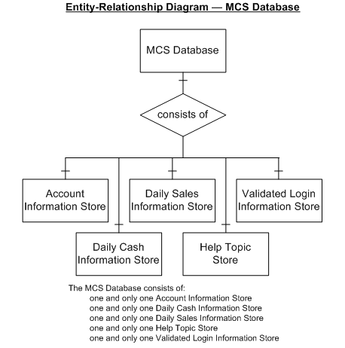
Figure 1. Monetary Counting System Context Entity-Relationship Diagram

The location of the models of the individual data stores can be found in Table 1 below.

Data Store Name | Paragraph Number | Page Number
Account Information Store | 1b | 6
Daily Cash Information Store | <as applicable> | <as applicable>
Daily Sales Information Store
Help Topic Store
Validated Login Information Store
Table 1. Data Store Cross-Referencing

Entity-Relationship Diagram – Account Information Store

The Account Information Store illustrated in Figure 2 below is one of the data stores that comprise the Monetary Counting System’s Database.

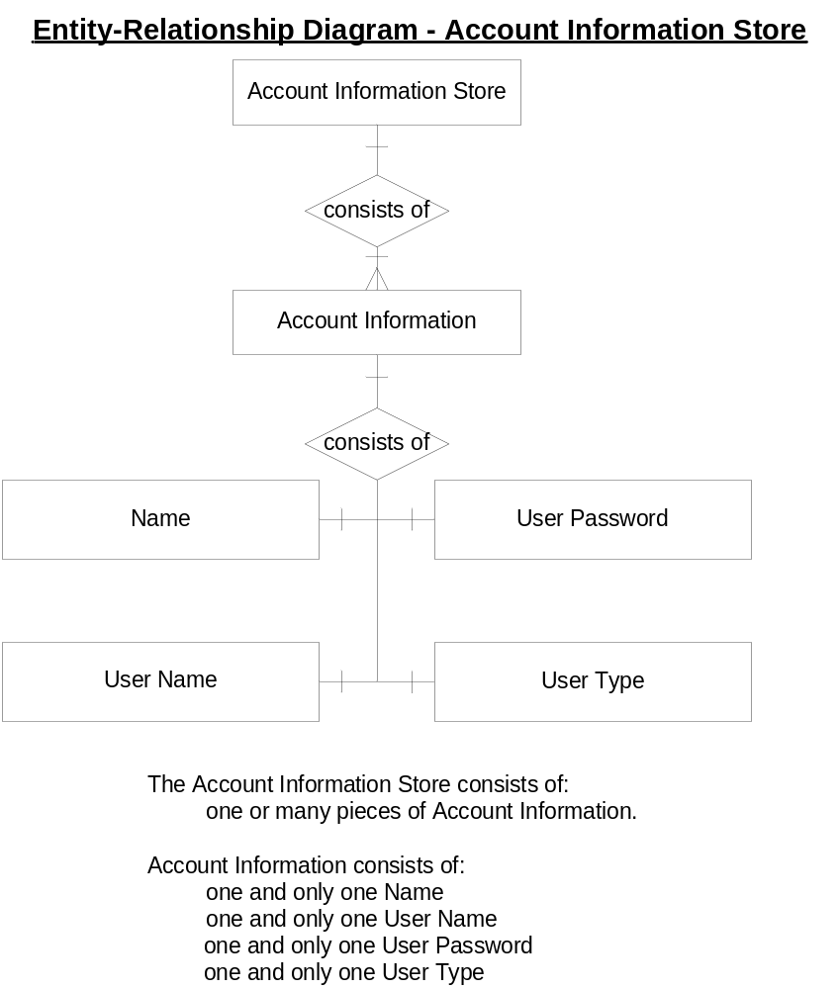
Figure 2. Account Information Store Entity-Relationship Diagram

Entity-Relationship Diagram – Name

Account Information contains the compound attribute Name, which is modelled in Figure 3 below.

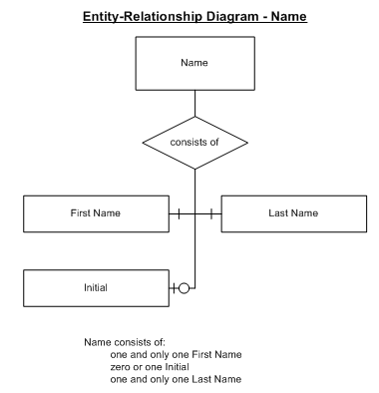
The next few pages would then contain all of the ERDs for the remaining datastores (in alphabetical order) that make up the Monetary Counting System database. These ERDs would be modeled down to the lowest level that you require for you analysis.

Then, the external stores would be modeled as detailed as necessary for their use with the system you are developing.

Figure 3. Name Entity Relationship Diagram

Object-Relational Models (ORMs)
Object-Relational Models show the relationship between a class and a data store and as such illustrate the persistency of classes. These classes are listed in alphabetical order.

Account Class ORM

One or more instances of Account can access the one Account Information Store as illustrated in Figure 4 below.

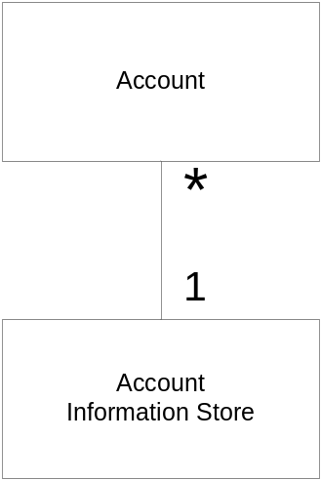

Figure 4. Account Class ORM

Usage Class ORM

One or more instances of Usage can access the one Validated Login Information Store as illustrated in Figure 5 below.

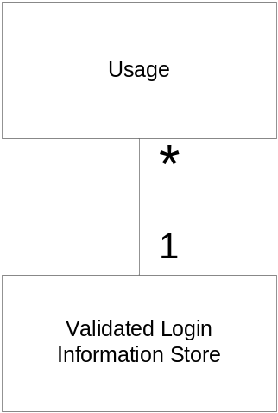
Figure 5. Usage Class ORM
Functional Description
Software transforms information, and in order to accomplish this, it must perform at least three generic functions: input, processing, and output. The functional model begins with the system being represented as a single context level model that captures the users of the system and the data that the system produces and consumes. To group all of the use cases identified in the behavioural model together as a system, a high-level use case diagram of the system is provided. To better understand the functionality provided by the system, each of the use cases is separately elaborated to identify other internal use cases that are necessary to realize the required functionality. Finally, once these usage scenarios have been developed for the system, the candidate classes, their responsibilities, collaborators, and encapsulated data (attributes) are identified as one homogenous unit in the form of an Extended Class-Responsibility-Collaborator (CRC) Card.

System Context Diagram Model
The first operational analysis principle required an examination of the information domain and the creation of a data model. The functional model begins with a single context level model that illustrates the system to be built.

Context Diagram

The MCS Level 0 DFD depicted in Figure 6 below contains all of the external entities that produce or consume data and an external data store that provides data that is essential to the operation of the MCS. As such, the context diagram assists in bounding the scope of the software requirements and also assists in determining the system interfaces.
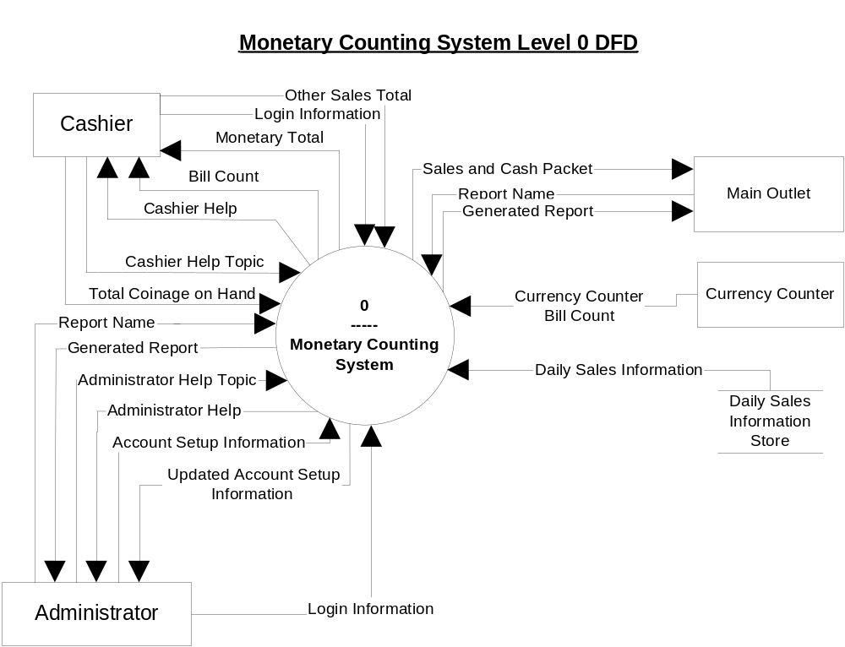
Figure 6. Monetary Counting System Level 0 DFD
The MCS is the software system that will be developed to meet the requirements of the MCS SOS. Table 2 outlines the usage of this software system at its highest level, with each software requirement cross-referenced to the functional requirements identified in the MCS SOS.

Functional  Requirement  Number | Software  Requirements  Use Case  Number | System Usage Narrative
SWE1  SWE2 | UC1  UCs renumbered – only one UC here, 4 ETDs | To login to the MCS a Cashier or Administrator can supply Login Information to the MCS. Once validated as either a Cashier or an Administrator, the Cashier or Administrator may have access to functionally applicable to their terms of usage.
SWE3 | UC2 | In order for the Administrator to create, to modify, and to delete cashier and administrator accounts, the Administrator can supply Account Setup Information to the MCS. The Updated Account Setup Information will be returned to the Administrator for verification purposes.
SWE4 | UC3 | The MCS can use the external Currency Counter to count various denominations of currency, the total of which is sent from the Currency Counter to the MCS as Currency Counter Bill Count, which in turn is sent from the MCS to the Cashier as Bill Count.
SWE5 | UC4 | The MCS can retrieve the Daily Sales Information from the Daily Sales Information Store, which is part of an external database associated with the client-supplied Cash Register software.
SWE5 | UC5 | The Cashier can cause the MCS to transmit a Sales and Cash Packet to the company's Main Outlet.
SWE6 | UC6 | The Cashier can provide the MCS with a manually counted Total Coinage on Hand. The MCS will use the Bill Count and Total Coinage on Hand values to calculate and to return Monetary Total to the Cashier.
SWE6 | UC7 | The MCS can also automatically save the Bill Count, the Monetary Total, and the Total Coinage on Hand to the internal MCS database when the Cashier transmits a Sales and Cast Packet.
SWE7 | UC8 | The Cashier can enter a Cashier Help Topic and the MCS will return Cashier Help to the Cashier.
SWE7 | UC9 | The Administrator can enter an Administrator Help Topic and the MCS will return Administrator Help to the Administrator.
SWU1 | UC10 | The Administrator can locally generate hourly, daily, weekly, and monthly reports using data extracted from the internal MCS database and/or the external Daily Sales Information Store. To do so, the Administrator supplies the MCS with the Report Name, and the MCS returns the Generated Report to the Administrator.
SWU2 | UC11 | The Cashier can provide the MCS with a manually counted Other Sales Total, which includes debit card and VISA/MASTERCARD sales totals.
SWD1 | UC12 | The Administrator can remotely (from the Main Outlet) generate hourly, daily, weekly, and monthly reports using data extracted from the internal MCS database and/or the external Daily Sales Information Store. To do so, the Main Outlet supplies the MCS with the Report Name, and the MCS returns the Generated Report to the Main Outlet.
SWD2 | UC13 | The MCS can count and correctly display totals of American currency in UC4.
Table 2. System Usage Narrative

System High-Level Use Case Model
The purpose of the system high-level use case diagram is to collect together all of the use cases identified in the behaviour model, and thus actors’ communication with the system, without revealing any of the internal workings of the system. All of the external actors that use the system are illustrated, and the primary use cases that they require to achieve the desired functionality realized by the implementation of the functional requirements in the SOS are depicted. A subsequent cross-referencing table identifies where the elaborated use case diagram for each high-level use case is located within the document.

High-Level Use Case Diagram

The MCS High-Level Use Case Diagram depicted in Figure 7 below illustrates MCS functionality as a collection of use cases. The cross-reference table contains information directly extracted from the behaviour use case – the number, name, actor/external entity and the description, and a cross-reference to identify where the elaborated use case diagram for each high-level use case is located within the document.

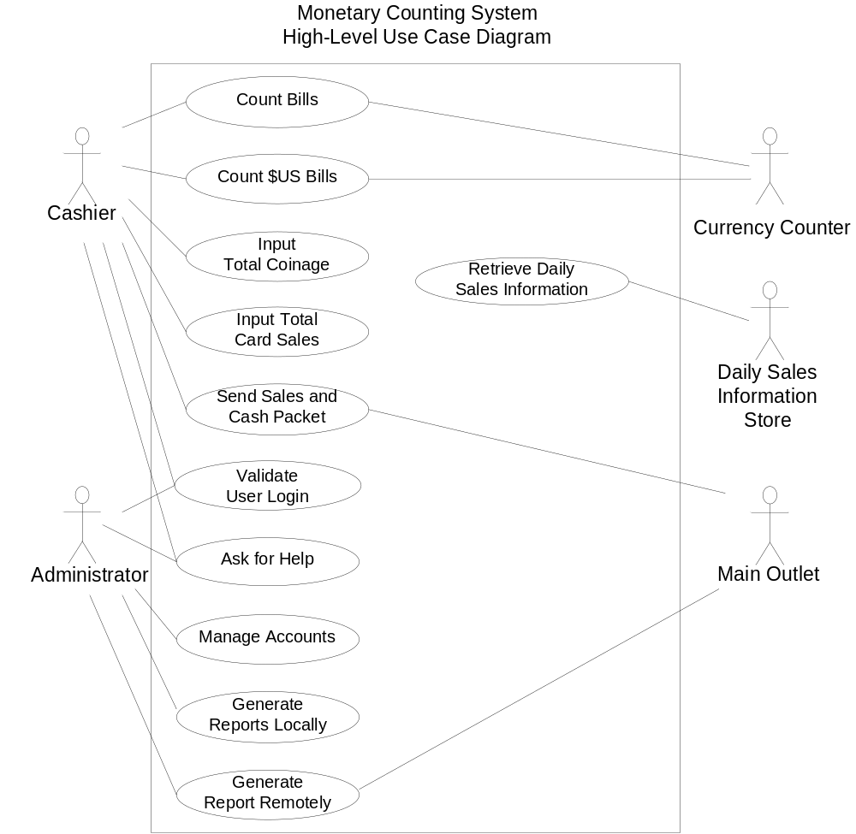
Figure 7. Monetary Counting System High-Level Use Case Diagram
The location of the detailed breakdown of each of the identified use cases is contained Table 3 below.
New table format and content – based upon Whitten 6th edition
High-Level  Use Case | Use-Case Description | Participating Actors and Roles | Elaborated Use Case | Behavioural  Event Trace Diagram (ETD)
UC1 – Validate User Login | This use case describes the event of a user logging into the system. | Cashier  Administrator | 5a Elaborated Use Case – UC1 Validate User Login | 1 ETD1 – Normal UC1 – Cashier Successfully Logs into MCS  2 ETD2 – Abnormal UC1 – Cashier Unsuccessfully Logs into MCS  1 ETD3 – Normal UC1 – Administrator Successfully Logs into MCS  2 ETD4 – Abnormal UC1 – Administrator Unsuccessfully Logs into MCS
<UC2 – UC7 would be here>
UC8 – Ask for Help | This use case describes the event of a user asking for help to use the product. | Cashier, Administrator | 5b Elaborated Use Case – UC8 Ask for Help | 7k1 ETD5 – Normal UC9 – Ask for Help by Administrator  7k2 ETD6 – Abnormal UC9 – Ask for Help by Administrator  7l1 ETD7 – Normal UC10 – Ask for Help by Administrator  7l2 ETD8 – Normal UC10 – Ask for Help by Administrator
<and so on>
Table 3. High-Level Use Case Glossary
Notes: New Comments

In the above example, 7l1 – 7l2, ETD5 – ETD8 are not included in the Behavioural section; however, they would be if the document was complete. Cross-references are in the form <para><sub-para>(<sub-sub-para>) i.e. 5a, 7a1, 7l1.

Whitten calls "elaborated" use cases "extension" use cases – see page Whitten 6th edition, page 445

The above table content and its name are based up Figure 7-10 in Whitten 6th edition.

Note that all tables and figures are captions, and any references to tables, figures, or paragraph headings are cross-references. Using these features of the word processor will ensure that if the document changes, then you will not have to waste time manually renumbering these items. Once again – quality – saving rework time if pages are added/deleted from the document.

Elaborated Use Case Diagram Models
The purpose of the high-level use case diagram is to detail the internal relationships each of the high-level use cases have with other use cases. Note that these relationships have their origins in the behavioural model’s uses case descriptions/ETDs – they are uses cases that identify events internal to the system. Eventually, the use cases must belong to a specific class. Thus, correlation between the high-level use case diagrams, the elaborated uses, the behaviour models, and the Class Responsibility and Collaboration (CRC) cards is paramount. A subsequent cross-referencing table after each elaborated use case identifies the CRC card for the class that will eventually implement the use case functionality.

Elaborated Use Case – UC1 Validate User Login
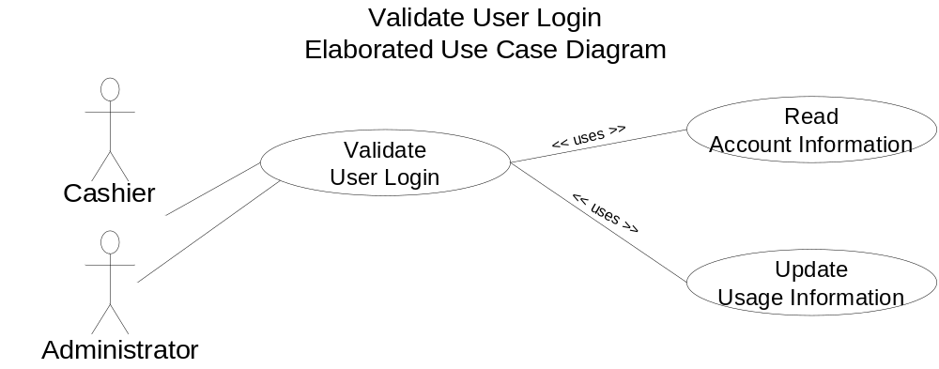
Figure 8. Elaborated Use Case – UC1 Validate User Login

Number: | UC1
Name: | Validate User Login
Actor/External Entity: | Cashier, Administrator
Description: | Prior to using any of the main functionality associated with the MCS, the user of the system must login and be validated. As part of validation, Validate User Login uses Read Account Information. Once validation is successful, Update Usage Information will be used to track a user.
Use Case – CRC Paragraph Number Cross-Reference : | Validate User Login | 6c Logon Class
 | Read Account Information | 6a Account Class
 | Update Usage Information | 6d Usage Class

Table 4. Elaborated Version of UC1 Validate User Login Use Case Narrative
New name for table, based upon Whitten Figure 7-12

<Elaborated Use Cases for UC3 – UC7 are modeled here>

Elaborated Use Case – UC8 Ask for Help

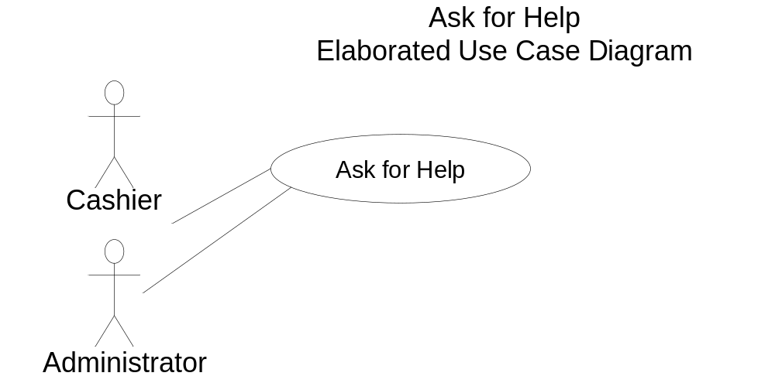
Figure 9. Elaborated Use Case – UC8 Ask for Help

Table 5. Elaborated Version of UC8 Ask for Help Use Case Narrative

<Other Elaborated Use Cases are modeled here>

Number: | UC8
Name: | Ask for Help
Actor/External Entity: | Cashier, Administrator
Description: | A Cashier can ask for help pertaining to the Cashier’s functionality, while the Administrator can ask for help pertaining to the Administrator’s functionality.
Use Case – CRC Paragraph Number Cross-Reference : | Ask for Help | 6b Instruction Manual Class

Extended Class-Responsibility-Collaborator (CRC) Cards
Once usage scenarios have been developed for the system, the candidate classes, their responsibilities, collaborators, and encapsulated data (attributes) must be identified as one homogenous unit. This subsection of the analysis document contains individual CRC cards in alphabetical order for each candidate class.
Note that there would certainly be others here – i.e. Administrator’s Create, Read, Delete and Update use cases

Account Class
The purpose of Account is to manage Account Information.
Class Name: | Account | Use Case Cross Reference Paragraph Number:  5a Elaborated Use Case – UC1 Validate User Login
Responsibilities: | - Creates Account Information  - Deletes Account Information  - Reads Account Information  - Updates Account Information | Collaborations:  None  Because the class responsibilities are not sequential in nature in this class, PDL in the analysis document may take the form illustrated here. NEW NEW NEW
Attributes: | Account Information
Table 6. Account Class

Instruction Manual Class
The purpose Instruction Manual is to provide on-line help to users.
Class Name: | Instruction Manual | Use Case Cross Reference Paragraph Number:  5b Elaborated Use Case – UC8 Ask for Help
Responsibilities: | - Accepts Administrator Help Topic and provides Administrator Help  - Accepts Cashier Help Topic and provides Cashier Help | Collaborations:  None
Attributes: | Administrator Help  Administrator Help Topic  Cashier Help  Cashier Help Topic
Table 7. Instruction Manual Class

Logon Class
The purpose of Logon is to safeguard the system from unauthorized users and to assign user roles to specific users.
Class Name: | Logon | Use Case Cross Reference Paragraph Number:  5a Elaborated Use Case – UC1 Validate User Login
Responsibilities: | - Accepts Login Information  - Reads Account Information  - Compares Login Information against Account Information  - If a match occurs:  - Updates Usage Information  - Presents Cashier with the Count Currency GUI  - Presents Administrator with the Administrator GUI  If no match occurs, return to 1. | Collaborations:  6a Account Class  6d Usage Class  Note that this CRC contains PDL in the analysis document because the class responsibilities are sequential in nature.
Attributes: | Account Information  Login Information  Usage Information
Table 8. Login Class

Usage Class
Note that this CRC is also incomplete.
The purpose of this class is to provide on-line help to users and to generate a usage report.
Class Name: | Usage | Use Case Cross Reference Paragraph Number:  5a Elaborated Use Case – UC1 Validate User Login
Responsibilities: | - Accepts Usage Information and stores it along with a time stamp  - Accepts Report Name and generates a Usage Information Report from stored Usage Information | Collaborations:  xx Usage Information Report Class
Attributes: | Report Name  Usage Information
Table 9. Usage Class

<Other classes are modeled here in alphabetical order>
Notes:

The Attributes in each of the aforementioned classes must correlate with other sections of the analysis document.

For example, if an attribute represents data that flows across the system boundary, then it must be correlated with the Context Diagram data flow name, the ETD and other models as applicable – e.g. Report Name in Usage class

If the attribute represents data that is internal to the system, then it must be correlated with the ETD and other models as applicable – e.g. Usage Information in Logon class and Usage class, Account Information in Logon class and Account class.

All of the attributes would be also contained in the data dictionary.

BEHAVIOURAL DESCRIPTION
System boundary use cases, coupled with event trace diagrams will model the system functions from the perspective of external users and in the manner and terminology they understand.

Behavioural Models – Event Trace Diagrams (ETDs) and Use Case (UC) Narratives
The models in the sections that follow depict a behaviourally related sequence of steps (a scenario), both automated and manual, for the purpose of completing a single domain-specific task. These use cases are summarized in Table 10 below.

New table format and content – based upon Whitten Figure 9 – 21. I have also changed my thought on Use Cases. For example, UC1 Validate User is just that – one use case. However, there may be many ETDs for various users. This is in line with my thoughts from 04W that were not implemented until now.

Participating Actors and Roles | High-Level Use | Trigger | Event (or Use Case) | Response
Cashier | UC1 – Validate User | Login GUI Request | 1 ETD1 – Normal UC1 – Cashier Successfully Logs into MCS | The user is validated as a Cashier, and is presented with the Count Currency GUI.
Cashier | UC1 – Validate User | Login GUI Request | 2 ETD2 – Abnormal UC1 – Cashier Unsuccessfully Logs into MCS | The user is not validated as a Cashier, and the Login GUI is presented to the user again.
Administrator | UC1 – Validate User | Login GUI Request | 1 ETD3 – Normal UC1 – Administrator Successfully Logs into MCS | The user is validated as an Administrator, and is presented with the Administrator GUI.
Administrator | UC1 – Validate User | Login GUI Request | 2 ETD4 – Abnormal UC1 – Administrator Unsuccessfully Logs into MCS | The user is not validated as an Administrator, and the Login GUI is presented to the user again.
Table 10. Use Case Table Cross-Referencing
Notes:

The above table has an entry for each ETD in this section.

Cross-references are in the form <para><sub-para><sub-sub-para> i.e. 7a1

The "Response" column is the ETD's "Conclusion."

Note that all tables and figures are captions, and any references to tables, figures, or paragraph headings are cross-references. Using these features of the word processor will ensure that if the document changes, then you will not have to waste time manually renumbering these items. Once again – quality – saving rework time if pages are added/deleted from the document.

Validate User Login – as Cashier
New format

ETD1 – Normal UC1 – Cashier Successfully Logs into MCS
Scenario: | A user attempts to login as a Cashier with valid Login Information.
Conclusion: | The user is validated as a Cashier, and is presented with the Count Currency GUI.
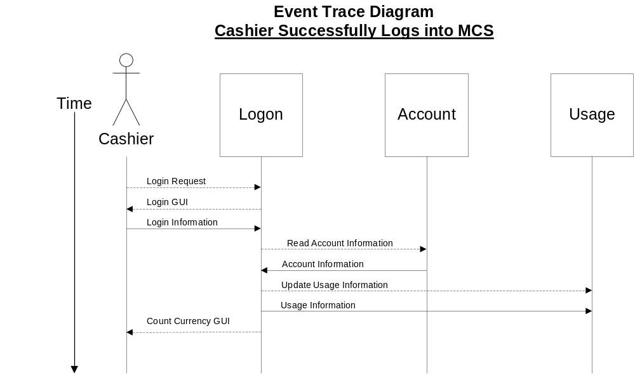
Figure 10. Cashier Successfully Logs into MCS

ETD2 – Abnormal UC1 – Cashier Unsuccessfully Logs into MCS
Scenario: | A user attempts to login as a Cashier with invalid Login Information.
Conclusion: | The user is not validated as a Cashier, and the Login GUI is presented to the user again.
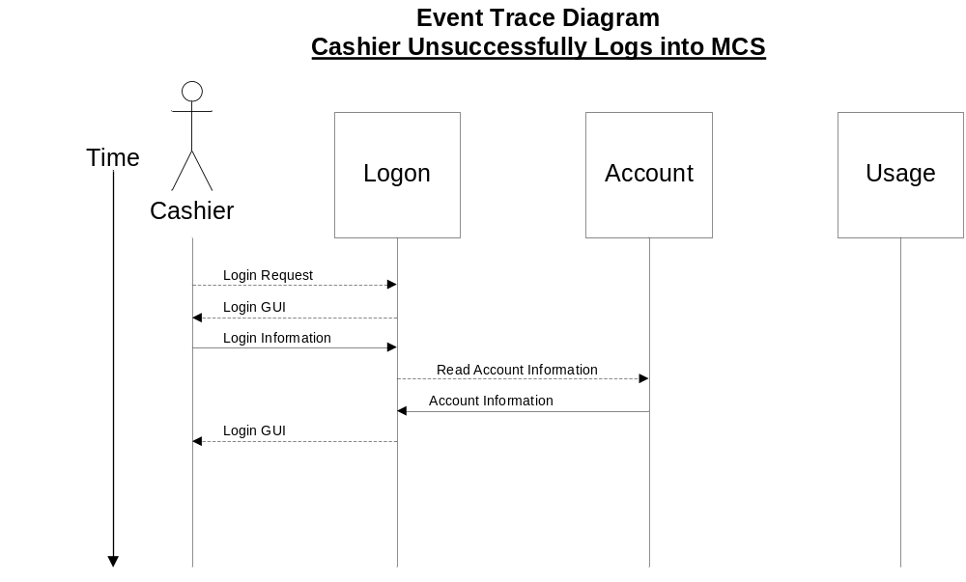
Figure 11. Cashier Unsuccessfully Logs into MCS

Number: | UC1
Name: | Validate User Login
Actor/External Entity: | Cashier
Description: | This use case describes the process of a Casher login to the system. On completion, the Cashier will be presented with the Count Currency GUI.
References | SWE1, SWE2  ETD1, ETD2
Typical Course Of Events: | External Entity/Actor Action | System Response
 | Step 1: This use case is initiated by a Cashier’s Login Request. | Step 2: The Cashier is presented with the Login GUI.
 | Step 3: The Cashier supplies Login Information
 |  | Step 4: A Read Account Information request to Account retrieves Account Information, which is compared against the Login Information for a match.
 |  | Step 5: If a match exists in Step 4, Usage is issued an Update Usage Information request and provided with Usage Information.
 | Step 6: This use case concludes when the Cashier is presented with the Count Currency GUI.
Alternate Courses: | Step 5: A match does not exist in Step 4, so the Cashier is taken back to Step 2.
Pre-Condition: | Account Information exists for the particular Cashier.
Post-Condition: | The Cashier may now use the Count Currency GUI.
Comments: | See Account Class ORM on page 8  See Usage Class ORM on page 8
Table 11. Use Case 1 - Validate User Login as Cashier
We forget the cross-reference to the ORMs
Notes:

See Whitten 6th edition "Step 4: Document Business Requirements Use-Case Narratives" pages 280 – 285 for other items that could be in these tables.

Whitten 6th edition, pages 446 – 450 contains other examples of these tables.

In all cases, the "Typical Course of Events" must explicitly match the names on the diagrams. Neither Whitten nor Pressman stress this point; however, it is imperative that this level of quality exists here so that project rework is minimized, thus resulting in faster delivery times – read the third myth on page 15 of Pressman 6th edition.

Validate User Login – as Administrator

ETD3 – Normal UC1 – Administrator Successfully Logs into MCS
Scenario: | A user attempts to login as an Administrator with valid Login Information.
Conclusion: | The user is validated as an Administrator, and is presented with the Administrator GUI.
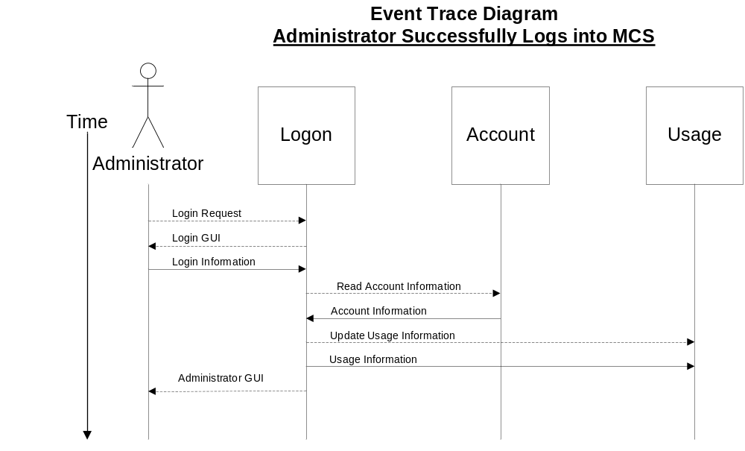
Figure 12. Administrator Successfully Logs into MCS

ETD4 – Abnormal UC1 – Administrator Unsuccessfully Logs into MCS
Scenario: | A user attempts to login as an Administrator with invalid Login Information.
Conclusion: | The user is not validated as an Administrator, and the Login GUI is presented to the user again.
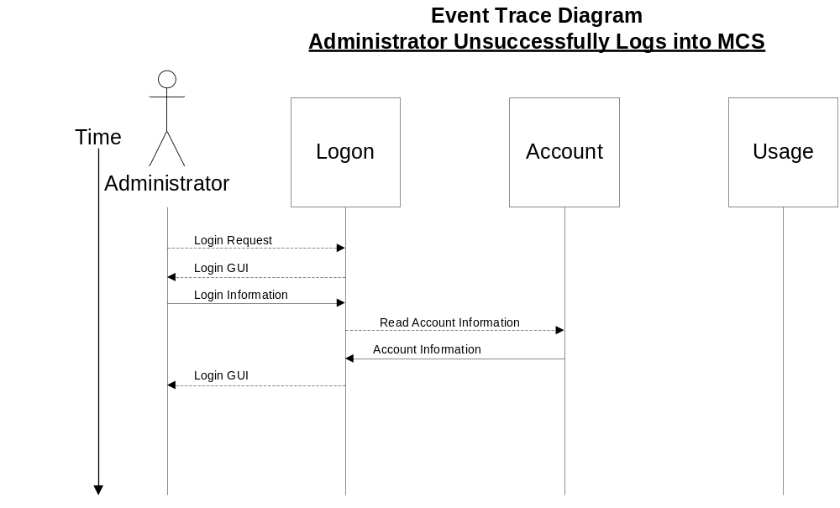
Figure 13. Administrator Unsuccessfully Logs into MCS
Number: | UC1
Name: | Validate User Login
Actor/External Entity: | Administrator
Description: | This use case describes the process of an Administrator login to the system. On completion, the Administrator will be presented with the Administrator GUI.
References | SWE1, SWE2  ETD3, ETD4
Typical Course Of Events: | External Entity/Actor Action | System Response
 | Step 1: This use case is initiated by an Administrator’s Login Request. | Step 2: The Administrator is presented with the Login GUI.
 | Step 3: The Administrator supplies Login Information
 |  | Step 4: A Read Account Information request to Account retrieves Account Information, which is compared against the Login Information for a match.
 |  | Step 5: If a match exists in Step 4, Usage is issued an Update Usage Information request and provided with Usage Information.
 | Step 6: This use case concludes when the Administrator is presented with the Administrator GUI.
Alternate Courses: | Step 5: A match does not exist in Step 4, so the Administrator is taken back to Step 2.
Pre-Condition: | Account Information exists for the particular Administrator.
Post-Condition: | The Administrator may now use the Administrator GUI.
Comments: | See Account Class ORM on page 8  See Usage Class ORM on page 8

Table 12. Use Case 2 - Validate User Login as Administrator
Note: This section of the document continues on, modeling all system boundary use cases so that all functional requirements are behaviourally depicted at the system level. These use cases form the foundation for system testing from a black-box perspective, and the validation that the functional requirements have been fully satisfied.

The MCS has the following system boundary use cases as identified in Figure 7. Monetary Counting System High-Level Use Case Diagram on page 11. Each of these use cases are broken up into Behavioural Models – Event Trace Diagrams (ETDs) and Use Case (UC) Narratives, as appropriate. (REWORDED)

Count Bills  Count $US Bills  Input Total Coinage  Input Total Card Sales  Send Sales and Cash Packet | Validate User Login  Ask for Help  Manage Accounts  Generate Reports Locally  Generate Report Remotely  Retrieve Daily Sales Information

Appendix A – Data Dictionary
Monetary Counting System Data Dictionary

Class Attributes

Account Class

Attribute Name | Use | Functional Requirement Number | Notational Description | Cross-Reference Paragraph Number
 |  |  |  | ERD | Context  Diagram | UC | CRC | ETD
Account Information | Information read from Account Information Store | SWE4 | Account Information = Name + User Name + User Password + User Type | 1b | 3a | 5a | 6a | 7a, 7b
<other attributes as discovered>

<Other classes are modeled here in alphabetical order>

Data Store, Data Flow or Entity

Data Store, Data Flow or Entity | How Used / Where Used | Functional Requirement Number | Notational Description | Cross-Reference
 |  |  |  | ERD | DFD | UC | TSD
Account Information | Information read from Account Information Store | SWE4 | Account Information = Name + User Name + User Password + User Type | Fig 2 | 1, 1.2 | 1, 2 | 1,2,3,4
Account Information Store | An internal data store that stores Account Information | SWE4 | Account Information Store = 1{Account Information}n | Fig 1, Fig 2 | 1, 1.2 | 1, 2 | 1,2,3,4
Administrator | External Entity | SWE2 | Administrator = * a type of user required by the system * |  | 0 | 2 | 1,2,3,4
Cashier | External Entity | SWE2 | 1{Cashier}n = * a type of user required by the system * |  | 0 | 1 | 1,2,3,4
First Name | Part of Name | SWE3 | First Name = * user's first name * | Fig 3
Last Name | Part of Name | SWE3 | Last Name = * user's last name * | Fig 3
Login Information | Input from Administrator or Cashier | SWE3 | Login Information = Login Name + Login Password |  | 0, 1 | 1, 2 | 1,2,3,4
Login Name | Forms part of Login Information | SWE3 | Login Name = * a unique login name associated with a unique Administrator or a unique Cashier * |  | 1.1
Login Password | Forms part of Login Information | SWE3 | Login Password = * a unique login password associated with a unique Administrator or a unique Cashier * |  | 1.3
Middle Initial | Part of Name | SWE3 | Middle Initial = * user's middle initial * | Fig 3
Name | Each user's proper name | SWE3 | Name = First Name + (Initial) + Last Name | Fig 2
User Name | Forms part of Account Information | SWE3, SWE4 | User Name = * a unique name assigned to a user by the Administrator in order to login to the system * | Fig 2
User Password | Forms part of Account Information | SWE3, SWE4 | User Password = * a unique password assigned to a user by the Administrator in order to login to the system * | Fig 2
User Type | Forms part of Account Information | SWE3, SWE4 | User Type = [ Administrator | Cashier ] | Fig 2
Validated Login Information | An output from a level 1 process to internal Validated User Login Information Store | SWE2, SWE3 | Validated Login Information = * Login Information that has been validated * | Not modeled yet | 1.1, 1.3 | 1, 2 | 1,2,3,4
Validated Login Information Store | An internal data store that stores Validated Login Information | SWE2, SWE3 | Validated Login Information Store = 1{Validated Login Information}n | Fig 1, Fig? | 1.3 | 1, 2 | 1,2,3,4

Note: The data dictionary in this example is not complete.

